‘Cutie Pie’ Sour Cherry, New for 2021 By Bob Bors
Released on the 100th anniversary of Horticulture
at the University of Saskatchewan

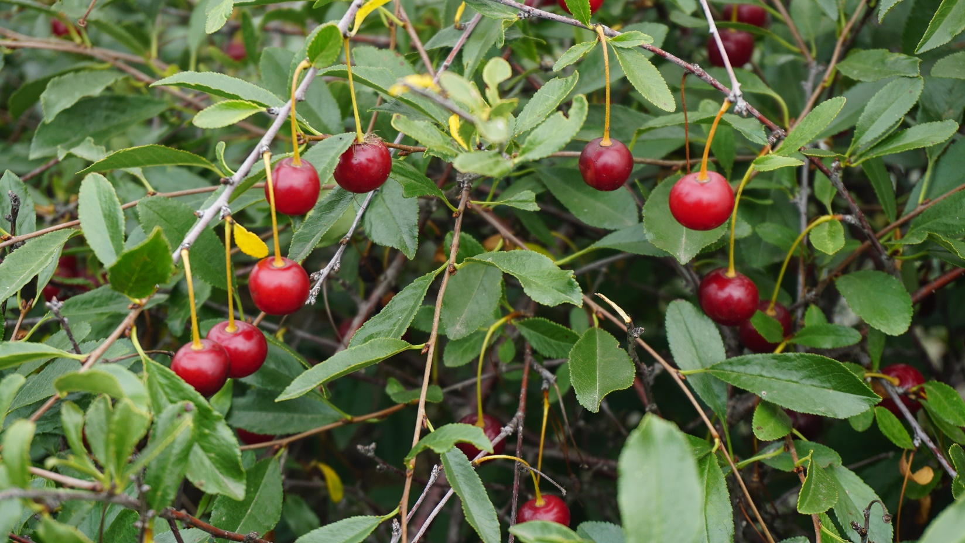

History
‘Cutie Pie’ is a grandchild of Les Kerr’s secret breeding program. Sometime in the 1940s while working for the federal government in Manitoba, Les Kerr began interbreeding Mongolian sour cherries (Prunus fruticosa) and European Sour cherries (Prunus cerasus). When he became head of the Forestry Farm Shelterbelt Centre in Saskatoon (part of the federal government) he was supposed to be breeding only shelterbelt plants. But he never gave up on his goal to create hardy sour cherries for the Prairie. He continued making crosses among superior plants but all the plants were planted at various friends farms to avoid the scrutiny of his Ottawa superiors. In total he worked about 40 years on this project! During the last few weeks of his life when he was hospitalized, he sought the advice of George Krahn of Lakeshore nursery about what to do with his hidden treasures. George convinced him to donate the collection to the University of Saskatchewan breeding program which at the time was under the direction of Dr. Cecil Stushnoff with Rick Sawatzky as the head technician. Les informed them which farms to visit to see his best cherries. Stushnoff and Sawatzky visited the best farms gathering fruit for seeds and cuttings which were then grown at both the University of Saskatchewan and Lakeshore nursery. When those seedlings grew up, Rick Sawatzky scrutinized the Lakeshore collection and gathered seeds for the next generation to be grown at the University. ‘Cutie Pie’ resulted in the next generation. It was selected for being unusually dwarf, sweet, and having bright red cherries. Having personally tasted a few hundred Mongolian European hybrids at one of our former testing spots, I can attest that most are extremely sour and Cutie Pie is the best tasting of that type.
Description
‘Cutie Pie’ has tasty, bright red cherries that are smaller than other cherries, about the size of a penny. At 7 years old the most recent planting is about 4 feet tall which is half the height of the Carmine Jewel cherries planted next to it. An earlier planting, on perhaps poorer soil, got only 2.5 feet after 20 years. It suckers and forms a tight hedge. Its background suggests that it might be hardier than other cherries and perhaps could do well in zone 2. Maybe Zone 1 with protection?
Birds do like cherries, but this one would be easier to net since the plant is smaller. Maybe a commercial cherry grower could use this as an alternate host to commercial cherries. I’ve notice birds tend to prefer smaller fruit since they are more bite size. But also they will eat the outer rows of a field first. Perhaps it could be desirable for bird lovers to plant.
This could also make a show hedge plant for landscaping purposes. It would have nice white flowers in spring.
For more information, download “Growing and Using University of Saskatchewan Sour Cherries” from www.fruit.usask.ca .

